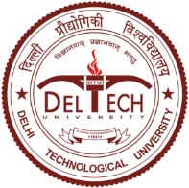
DELHI TECHNOLOGICAL UNIVERSITY
(Formerly Delhi College of Engineering)
Shahbad Daulatpur, Main Bawana Road, Delhi-42

DECLARTION
COURSE CODE:
TITLE:

It is to certify that I have prepared all the Multiple Choice Questions (MCQs) myself and the questions included in the question paper are not “as it is” taken from internet.

Signature
Name:
Designation:
Department:

